Name __________________________________________ Date ____________________
The next section of Star Spangled Banner has quite a few E string notes as well:
(1) The first three notes are F# 1 finger on E string, G “hugging” 2nd finger, then A 3 fingers:
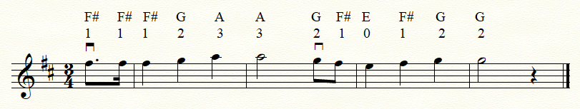

(2) After going down, you go back up on A string then up the D string notes:
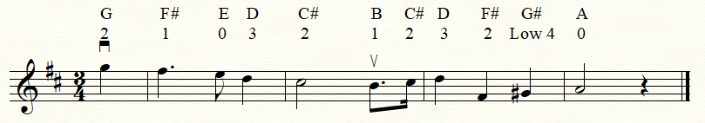

(3) Put the two parts together and you get the following:
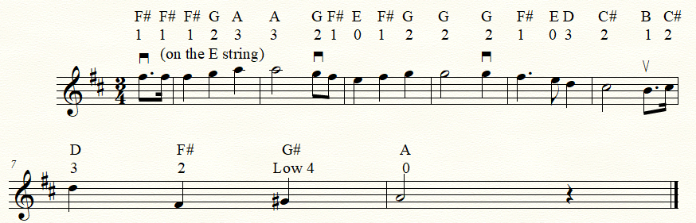

(4) Now add it to what you already know and you have this:


