Name __________________________________________ Date ____________________
The next section of Star Spangled Banner contains notes you are already familiar with:
(1) This section contains primarily D & A string notes:
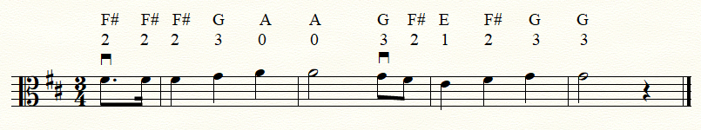

(2) This section contains C#’s & G#’s, so be careful:
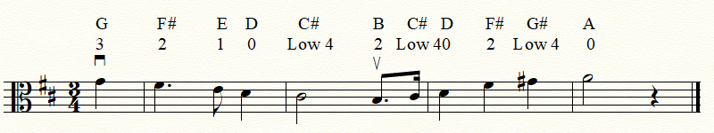

(3) Put the two parts together and you get the following:
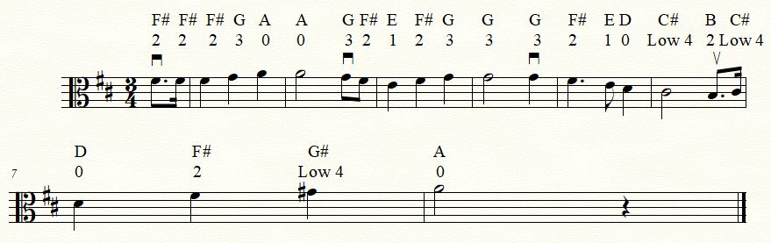

(4) Now add it to what you already know and you have this:


