Name __________________________________________ Date ____________________
The last section of Star Spangled Banner contains notes you are already familiar with:
(1) This section contains primarily A & D string notes, but there is an extended 4th finger C# on G string as well. It also has a fermata (the “bird’s eye” sign above low C#) that means to hold that note until I show you to stop:
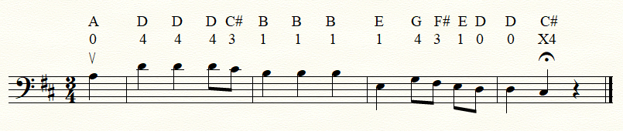

(2) This section contains notes on G, D, & A Strings:
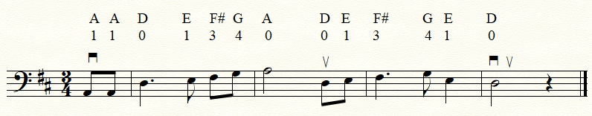

(3) Put the two parts together and you get the following:
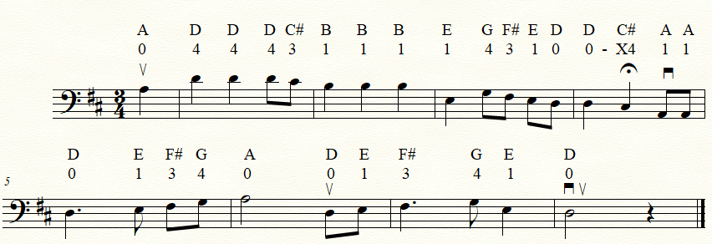

(4) Now add it to what you already know and now you know the whole song!!!!
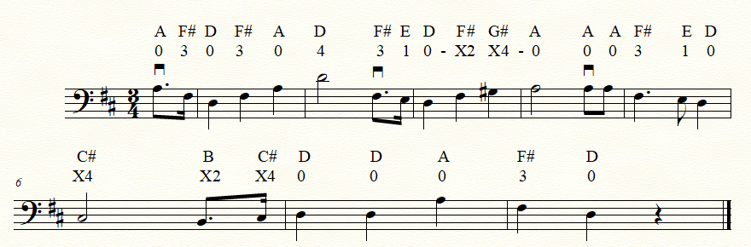**Play this section twice!!!!**


